VAC TECHNICAL REPORT
Inside the VAC Schwarzschild
Black Hole Simulation
Physics, mathematics, numerical integration, and the WebGL rendering pipeline
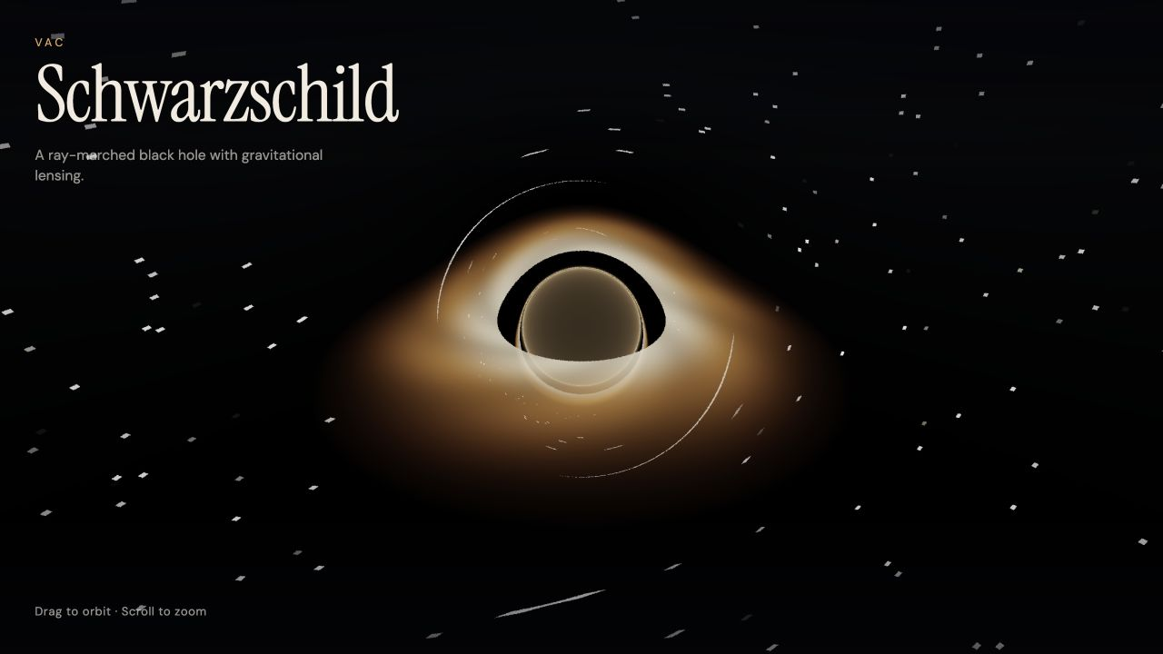
Live WebGL2 render from the current VAC code snapshot
31 July 2026
Repository branch: optimize | Commit: 6904ea0

00 Executive summary
What the project is, what it computes, and how to read the visuals

Abstract
The VAC project is a real-time WebGL2 visualization of light bending around a nonspinning Schwarzschild black hole. For every screen pixel, the fragment shader launches a camera ray, advances its spatial path through a curvature-derived central acceleration, detects crossings of a thin equatorial accretion disk, and stops when the ray is captured or escapes. The result is an interactive image with a dark capture region, lensed views of the far side of the disk, and a procedural background.
The simulation is best described as a reduced null-geodesic ray tracer on a fixed Schwarzschild spacetime. It does not evolve Einstein's field equations, solve for a changing metric, simulate disk fluid dynamics, or perform physical radiative transfer. Several visible effects - the disk spiral, photon-sphere glow, redshift falloff, starfield, tone mapping, and vignette - are intentionally artistic or heuristic.
Central takeaway: The mathematical core is compact and meaningful: the shader reproduces the Schwarzschild spatial light-orbit equation, then surrounds it with an efficient GPU rendering model and a deliberately stylized emission model.
Implementation fact | Current value | Evidence
Spacetime model | Schwarzschild, fixed M = 1 | fragment.glsl 14-19
Ray integrator | Explicit midpoint RK2 | fragment.glsl 64-71
Maximum work | 260 steps per pixel | fragment.glsl 20, 105
Disk | Thin plane, 6M < r < 18M | fragment.glsl 18-19, 129-148
Interaction | Orbit, inertia, zoom | main.js 91-155
Runtime | Six-file static WebGL2 app | Local runtime audit

Use this language
- Accurate: real-time Schwarzschild null-ray visualization; reduced spatial geodesic integration; GPU ray tracing.
- Avoid: numerical-relativity merger simulation; full 4D covariant ray tracer; physically calibrated accretion-disk model.

01 From browser input to one image
The six files divide cleanly into interface, orchestration, and GPU physics

A deliberately small architecture
- index.html creates a full-window canvas and a minimal text overlay.
- style.css establishes the dark visual stage, responsive title treatment, and pointer affordances.
- main.js loads and compiles the shaders, maps user input into camera uniforms, and draws one full-screen triangle every animation frame.
- vertex.glsl emits that triangle without a vertex buffer; each fragment receives screen coordinates.
- fragment.glsl constructs a camera ray, integrates it, accumulates disk emission, and tone-maps the result.

The frame loop
input -> camera state -> uniforms -> full-screen draw -> one fragment program per pixel -> display
The JavaScript layer does not move geometry or evaluate the black-hole equations. It updates the camera and time, then transfers six scalar/vector uniforms to the GPU. The fragment shader owns the expensive work, which is why the same compact code can evaluate millions of rays in parallel.
Layer | Responsibility | Primary source
Presentation | Canvas, brand copy, error surface | index.html; style.css
Application | WebGL2 setup, input, camera, render loop | js/main.js
Geometry | Full-screen triangle and UV coordinates | shaders/vertex.glsl
Physics + image | Ray ODE, disk hits, background, tone map | shaders/fragment.glsl

Why one triangle: A single oversized triangle covers the viewport without a diagonal seam and avoids duplicated vertices. The actual scene exists procedurally inside the fragment shader; there are no 3D meshes or texture assets.

02 Schwarzschild geometry sets the scale
Geometric units make every distance a multiple of the black-hole mass

The background spacetime
For a spherical, nonrotating mass, the exterior geometry is described by the Schwarzschild metric. In geometric units G = c = 1, mass, distance, and time share compatible units:
ds² = -(1 - 2M/r) dt² + (1 - 2M/r)⁻¹ dr² + r²(dθ² + sin²θ dφ²)
Schwarzschild line element in standard coordinates
The shader chooses M = 1. To attach a physical mass later, one code length unit M corresponds to GM_phys/c², and one code time unit corresponds to GM_phys/c³. Because the current image is scale-free, the same dimensionless geometry can represent black holes of very different masses.

Four radii organize the scene
Radius | Role | How the code uses it
r = 2M | Schwarzschild horizon | Capture threshold at 1.02 x 2M
r = 3M | Unstable circular photon orbit | Center of an artistic near-photon glow
r = 6M | ISCO for massive particles | Inner edge of the thin disk
r = 18M | Chosen outer disk edge | Ends the visible disk; a design parameter
r = 70M | Numerical escape boundary | Stops rays and samples the starfield

Important distinction: The event horizon is a spacetime boundary at r = 2M. The apparent shadow in an image is larger and is controlled by which light paths are captured. The bronze center visible in this version is an added glow, not a rendering of the horizon surface.

03 The light path reduces to one nonlinear orbit equation
Spherical symmetry turns a 4D geometry problem into a planar spatial curve

From the metric to the orbital equation
A photon follows a null geodesic, so ds² = 0. Spherical symmetry guarantees that each orbit lies in a plane through the origin. Choosing that plane as the equatorial plane and using the conserved energy E and angular momentum L gives a first integral for u = 1/r:
(du/dφ)² = E²/L² - u² + 2Mu³
Differentiating with respect to the orbital angle φ gives the Schwarzschild null-orbit equation:
d²u/dφ² + u = 3Mu²
The 3Mu² term produces relativistic bending and the photon sphere

The shader's 3D vector form
The shader represents the same unparameterized spatial curve in Cartesian coordinates. With r-vector r, velocity v = dr/dλ, and specific angular momentum L = r x v, a central acceleration that reproduces the orbit equation is:
d²r/dλ² = -3M |L|² r / |r|⁵
Because RS = 2M, the implementation coefficient -1.5 RS is exactly -3M. The acceleration is purely radial, so the continuum trajectory remains planar and conserves the direction of L.
vec3 L = cross(pos, vel);
float L2 = max(dot(L, L), 1e-8);
return -1.5 * RS * L2 * pos / (r2 * r2 * r);
What is exact here: For the spatial orbit shape, the central-force form is equivalent to the standard Schwarzschild null-orbit equation.
What is omitted: The shader does not integrate the Schwarzschild coordinate time, a local observer tetrad, a full four-momentum, or frequency transport. Its camera ray is initialized in a Euclidean basis.

04 Explicit midpoint RK2 advances each ray
A second-order step balances stability, cost, and WebGL simplicity

State and update
The ray state is y = (r, v), with derivative f(y) = (v, a(r,v)). The shader uses the explicit midpoint Runge-Kutta method:
k₁ = f(yₙ), y_mid = yₙ + (h/2)k₁, yₙ₊₁ = yₙ + h f(y_mid)
Written in the code's position-velocity split, it evaluates acceleration at the current state, estimates a midpoint, evaluates acceleration again, then updates position and velocity with midpoint values. The method has second-order global accuracy when the solution is smooth and the step sequence is refined consistently.
a1 = geodesicAccel(pos, vel)
posMid = pos + 0.5 h vel
velMid = vel + 0.5 h a1
a2 = geodesicAccel(posMid, velMid)
pos = pos + h velMid; vel = vel + h a2

Curvature-aware step size
h(r) = clamp(0.045r, 0.025, 0.4)
Far from the black hole, the ray advances in larger steps. Near the strong-curvature region, the step becomes smaller. This is an efficient heuristic rather than an error-controlled adaptive integrator: it does not estimate local truncation error or reject a step.
Choice | Benefit | Tradeoff
RK2 | Two acceleration evaluations; compact GLSL | Less accurate than RK4 at equal step size
h proportional to r | More samples where curvature is stronger | No explicit error tolerance
260-step cap | Predictable shader cost | Some tightly wound rays may stop before escape
Linear plane hit | Cheap disk intersection | Hit location inherits step-size error

05 Each ray ends in capture, escape, or disk emission
The tracer converts a continuous curve into a small set of rendering events

Termination logic
Condition | Interpretation | Image action
r < 1.02 RS | Captured near the horizon | Set transmittance to zero and stop
r > 70M | Escaped the local scene | Sample the procedural starfield and stop
Disk plane crossing | Ray intersects y = 0 | Interpolate hit, add disk emission, continue
Transmittance < 0.02 | Prior hits dominate | Stop accumulating additional layers
260 steps | Work budget exhausted | Return color accumulated so far

Thin-disk intersection
A sign change between the previous y coordinate and the next y coordinate signals a crossing of the equatorial plane. Linear interpolation estimates the fractional position of the hit:
t_hit = y_prev / (y_prev - y_next), r_hit = mix(r_prev, r_next, t_hit)
If the cylindrical hit radius lies between 6M and 18M, the shader adds disk color and reduces transmittance to 35 percent. Continuing the ray after a hit lets one pixel collect more than one disk image when strong bending makes the path cross the plane repeatedly. That is the mechanism behind the wrapped far-side view.
Lensing is geometry, not a screen warp: The disk is not distorted after rendering. The code follows a curved ray first; the same flat disk is sampled wherever that ray crosses its plane.

06 Changing the camera reveals the lensing structure
The same scene produces different disk images because the launch direction changes
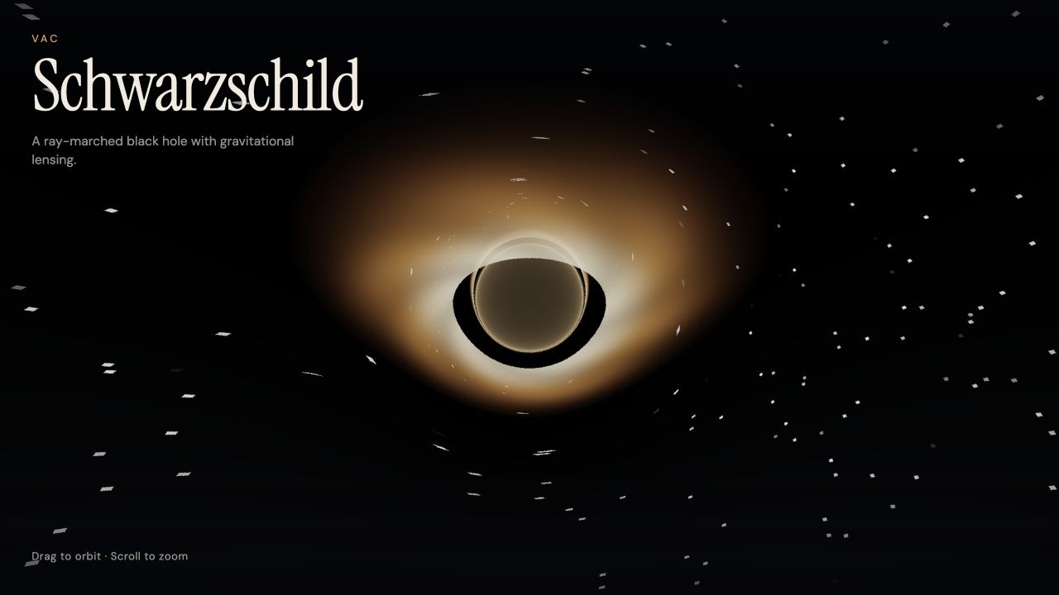
Figures 1-2. Default and near-edge-on views. Curved rays reveal direct and higher-order disk images.
Both images come from identical physics and emission code. Dragging changes azimuth and elevation; scrolling changes camera distance. The shader reconstructs a new camera basis and launches a different ray through each pixel. The strongest visual proof of lensing is the duplicated, curved image of disk material that would be hidden in a straight-line renderer.
Reading the center carefully: The black annular region and the bronze-filled center are renderer outputs, not literal surfaces. The shader adds near-photon-sphere glow after the integration loop even when a ray was captured, so the center should not be labeled as the event horizon itself.

07 The emission model turns ray events into color
Physics motivates the geometry; handcrafted functions control the visual appearance

Disk palette and spiral structure
The disk color interpolates from white-gold near the inner edge to amber and copper at larger radii. A sinusoidal pattern in azimuth, log radius, and time creates animated spiral bands. Brightness decays outward and is divided by radius:
B(r,φ,t) ∝ [0.72 + 0.28 sin(6φ - 8 ln r - 1.4t)] (1 - τ)¹·³⁵ / (0.18r)
Here τ is the normalized position between the disk's inner and outer radii. This function is visually effective, but it is not a temperature solution, fluid simulation, or emissivity law derived from disk dynamics.

Compositing and post-processing
Stage | Implementation | Scientific status
Redshift factor | Linear clamp based on hit radius | Heuristic; no frequency or observer motion
Opacity | Multiply transmittance by 0.35 per hit | Artistic thin-surface compositing
Photon glow | Accumulate near r = 3M | Artistic emphasis
Background | Hashed directional starfield | Procedural, not an astronomical catalog
Tone map | ACES-style rational curve | Display transform, not radiative physics
Gamma + vignette | Power 1/2.2 and radial darkening | Presentation choices

A useful design principle: Keep the geodesic solver and the emission model conceptually separate. That makes it possible to improve physical fidelity without discarding the renderer or the interaction design.

08 WebGL makes the calculation interactive
The GPU repeats the same bounded program for every pixel

Per-frame data flow
camera distance + azimuth + elevation + time + resolution -> fragment shader -> RGBA pixel
JavaScript updates the camera, clamps frame delta to 0.05 seconds, resizes the canvas, uploads uniforms, and issues one triangle draw. The shader then runs independently for every covered pixel. No depth buffer is needed because the image is generated by ray integration rather than rasterized scene geometry.

Performance-oriented choices
Choice | Why it helps | Source
Device pixel ratio capped at 1.75 | Limits fragment count on high-density screens | main.js 80-89
Antialiasing disabled | Avoids redundant multisample work | main.js 177-182
Fixed subpixel jitter | Softens edges without temporal sparkle | fragment.glsl 170-178
Adaptive spatial step | Spends iterations near strong curvature | fragment.glsl 124-127
Early exits | Stops captured, escaped, or opaque rays | fragment.glsl 108-117, 145-147
High-performance context hint | Requests a performance-oriented GPU path | main.js 177-182

At a 1280 x 720 viewport and device pixel ratio 1.75, the verified canvas was 2240 x 1260: more than 2.8 million fragments per frame. Each can run up to 260 RK2 steps, although many rays exit early.

Interaction
- Drag or touch changes azimuth and elevation; elevation clamps to approximately +/-1.2 radians.
- Release produces a short exponentially damped coast.
- Wheel zoom spans 12M to 55M; the default is 28M.

09 Validation should test mathematics, numerics, and pixels
A dramatic image is evidence of execution, not sufficient evidence of correctness

Recommended validation ladder
Test | Observable | Expected signature
Shader/runtime smoke | All five assets load; WebGL2 compiles | No error overlay or console errors
Planarity | Direction of L = r x v | Remains fixed within numerical error
Photon sphere | Tangential ray at r = 3M | Approximately circular orbit; drift shrinks with h
Weak-field deflection | Ray with large impact parameter b | Deflection approaches 4M/b
Step convergence | Reference ray at h, h/2, h/4 | RK2 global error approaches second order
Disk intersection | Known straight/weakly bent crossing | Hit radius converges under refinement
Visual regression | Fixed camera screenshots | No unexpected silhouette, color, or UI change
Performance | Frame time by viewport and GPU | Budget stated with hardware and resolution

Current verified baseline: The documented static-server command loaded all application assets with HTTP 200 responses, WebGL2 initialized, the error overlay remained hidden, the console reported no warnings or errors, and drag and wheel controls worked. The only HTTP blemish was a missing favicon request.
There is currently no package manifest, build system, unit test, shader test, reference integrator, or recorded visual regression suite. The validation ladder above is therefore a roadmap, not a claim that those tests already pass.

10 The scientific boundary is clear and manageable
Separating faithful geometry from proxies makes the demo easier to explain and improve
Grounded in relativity | Simplified or heuristic | Not modeled
Schwarzschild spherical geometry | Euclidean camera basis | Evolving Einstein field equations
Null spatial orbit equation | Spatial path only; no t coordinate | Binary black holes or mergers
Horizon, photon sphere, ISCO radii | Capture threshold at 1.02 RS | Kerr spin and frame dragging
Curved-ray disk crossings | RK2 with heuristic step rule | Disk magnetohydrodynamics
Multiple lensed disk images | Handcrafted emissivity and opacity | Physical radiative transfer
Scale-free geometric units | Procedural stars and post-processing | Doppler beaming and calibrated spectra

Recommended public description
One sentence: An interactive WebGL2 visualization that integrates reduced Schwarzschild light paths around a nonspinning black hole and samples a stylized thin accretion disk.

Why this is not full numerical relativity
Numerical relativity evolves the spacetime metric and constraints on a spatial grid. This project instead supplies an analytic Schwarzschild background and computes test-light trajectories within it. It is a substantial relativistic ray tracer, but it solves a different problem.

11 Known numerical artifacts are separate from the physics
Several visible edge cases come from work limits, stepping, or shader portability

Fixed work budget
The 260-step loop and maximum step h = 0.4 provide at most about 104 path-length units. A ray launched inward from the maximum 55M camera distance can require more than that to turn around and reach the 70M escape sphere. When the loop ends without capture or escape, the shader returns only accumulated color and does not add the starfield, so an escaping ray can appear spuriously dark.
Exploratory audit: A read-only emulation of the exact loop on a coarse 101 x 57 ray grid found budget exhaustion for about 1.7 percent of rays at the default 28M camera distance and about 32 percent at 55M. Continued sampled rays escaped rather than being captured. These figures are audit measurements, not a repository test or a universal screen-space rate.

Other implementation-sensitive effects
Issue | Consequence | Practical fix
Glow adds a fixed amount per step | Brightness changes when step size or step count changes | Scale by h or define an optical-depth integral
smoothstep edges are reversed | GLSL behavior is undefined when edge0 >= edge1 | Use 1 - smoothstep(0, 0.8, distance)
Single-precision near an unstable orbit | Fine photon rings and higher-order images are resolution-sensitive | Reference against a higher-precision CPU solver
Camera can move to 12M inside the 18M disk | Observer may sit within the modeled radial disk domain | Clamp outside the disk or label this exploration mode
Capture cutoff at 2.04M | Numerical guard slightly outside the formal horizon | Quantify sensitivity and reduce with safer coordinates

These issues do not erase the correct geodesic core. They define where the current implementation should be treated as a qualitative visualization and where targeted tests can improve reliability.

12 A staged roadmap can add fidelity without losing the demo
Improve the transfer physics and validation before attempting a different class of solver
Stage | Change | Why it matters
1. Validate | Offline reference integrator, invariants, step-halving, fixed-camera image tests | Turns visual confidence into measured confidence
2. Correct transfer | Observer tetrad, frequency shift, invariant intensity transport | Makes color and brightness physically interpretable
3. Improve disk | Orbital velocity, Doppler beaming, emissivity/temperature model | Adds the strongest missing observable asymmetry
4. Add Kerr | Spin parameter, frame dragging, Kerr null geodesics | Extends the spacetime while retaining ray-tracing architecture
5. Tune quality | Error-controlled stepping, optional supersampling, performance telemetry | Balances fidelity and interactivity

Separate horizon: A full numerical-relativity solver would be a new project: it would evolve the metric, constraints, and gauge fields on a spatial grid. It should not be presented as the next incremental shader feature.

Small product improvements
- Expose M-normalized camera radius and landmark radii in an optional information panel.
- Add reset, pause, quality, and physics-versus-art toggles.
- Add a scope note and gate the post-capture center glow when a black shadow is desired.
- Add a favicon and a reproducible screenshot command.

A Code-to-math map
Where each concept lives in the current source tree
Concept | Equation or algorithm | Source location
Geometric units | M = 1; RS = 2M | fragment.glsl 14-19
Landmark radii | 3M photon sphere; 6M ISCO | fragment.glsl 17-19
Geodesic acceleration | a = -3ML² r/|r|⁵ | fragment.glsl 54-62
RK2 | Explicit midpoint update | fragment.glsl 64-71
Camera ray | Orbiting Euclidean basis + perspective | fragment.glsl 73-95
Capture/escape | r < 1.02RS; r > 70M | fragment.glsl 105-118
Step size | clamp(0.045r, 0.025, 0.4) | fragment.glsl 124-127
Disk intersection | Plane sign change + interpolation | fragment.glsl 129-149
Disk emission | Palette, spiral, radial falloff | fragment.glsl 39-52
Post-processing | Tone map, gamma, vignette | fragment.glsl 161-188
Camera controls | Pointer orbit, inertia, wheel zoom | main.js 91-155
GPU frame | Uniform upload + triangle draw | main.js 157-175
WebGL setup | Compile/link, error handling | main.js 42-77, 177-220
Full-screen triangle | gl_VertexID -> three clip vertices | vertex.glsl 4-15

Snapshot rule: These line references match commit 6904ea0 on branch optimize. Re-check them if the shader or JavaScript changes.

B Run guide and source map
How to reproduce the demo and find the implementation evidence

Run locally
cd "Blackhole Simulation"
python3 -m http.server 8080
# Open http://localhost:8080
- Requires a browser with WebGL2 support.
- Drag with mouse or touch to orbit; scroll to zoom.
- The shader files are fetched at runtime, so opening index.html directly with file:// will fail in most browsers.

Primary project sources
ID | File | Coverage
C1 | Blackhole Simulation/README.md | Lines 1-29
C2 | Blackhole Simulation/js/main.js | Lines 1-223
C3 | Blackhole Simulation/shaders/vertex.glsl | Lines 1-16
C4 | Blackhole Simulation/shaders/fragment.glsl | Lines 1-189
C5 | Blackhole Simulation/index.html | Lines 1-28
C6 | Blackhole Simulation/css/style.css | Lines 1-121

C Scientific references
Primary and authoritative sources for the geometry, disk physics, and numerical method
[1] E. Belbruno and F. Pretorius, A Dynamical System's Approach to Schwarzschild Null Geodesics, 2011. Equation 12 gives the spatial vector equation used by the shader. Open reference
[2] J. M. Bardeen, W. H. Press, and S. A. Teukolsky, Rotating Black Holes: Locally Nonrotating Frames, Energy Extraction, and Scalar Synchrotron Radiation, Astrophysical Journal 178 (1972) 347-370. Open reference
[3] D. N. Page and K. S. Thorne, Disk-Accretion onto a Black Hole. Time-Averaged Structure of Accretion Disk, Astrophysical Journal 191 (1974) 499-506. Open reference
[4] C. T. Cunningham, The Effects of Redshifts and Focusing on the Spectrum of an Accretion Disk around a Kerr Black Hole, Astrophysical Journal 202 (1975) 788-802. Open reference
[5] Event Horizon Telescope Collaboration, Astronomers Capture First Image of a Black Hole, 2019. Official explanation of the observed shadow and event horizon distinction. Open reference
[6] K. Schwarzschild, On the Gravitational Field of a Mass Point According to Einstein's Theory, 1916; English translation. Open reference
[7] S. M. Carroll, Lecture Notes on General Relativity, sections on Schwarzschild geometry and geodesics. Open reference
[8] E. Hairer, S. P. Norsett, and G. Wanner, Solving Ordinary Differential Equations I: Nonstiff Problems, second edition. Open reference

Document scope
This report explains the implementation present in the VAC repository at the stated snapshot. Scientific sources support the background geometry and numerical framing; implementation claims are grounded in the local code and verified runtime behavior. No claim is made that the visual emission model is calibrated to observational data.

